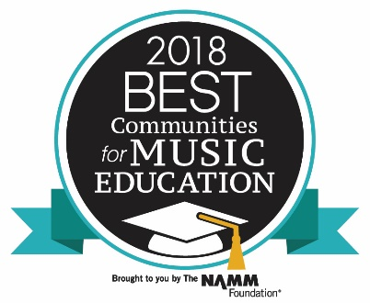
Wakefield, MA (April 17, 2018) – Wakefield Public Schools has been honored with the Best Communities for Music Education designation from The NAMM Foundation for its outstanding commitment to music education. Wakefield is one of 4% of districts across the nation and one of 14 school districts in Massachusetts receiving the prestigious award in 2018. This is the sixth time in the last seven years that Wakefield has been recognized with this award.

Now in its 19th year, Best Communities for Music Education affirms school districts that have demonstrated exceptional efforts toward maintaining music education as part of schools’ core curriculum.

The Best Communities for Music Education designation is awarded to districts that demonstrate outstanding achievement in efforts to provide music access and education to all students. To qualify for the Best Communities designation, Wakefield answered detailed questions about funding, graduation requirements, music class participation, instruction time, facilities, support for the music program, and community music-making programs. Responses were verified with school officials and reviewed by The Music Research Institute at the University of Kansas.
“I am very proud of the Wakefield Community, Wakefield Music Boosters and the Wakefield School Department for their continued support of music in the town of Wakefield. This is a K-12 designation, which shows the value that is put on music throughout the school system. Thank you to the school department, parents and especially the music teachers for all of their hard work and dedication to providing a quality music education for all students.” – Thomas Bankert, Wakefield Public Schools Director of Visual & Performing Arts

This award recognizes that Wakefield is leading the way with learning opportunities as outlined in the Every Student Succeeds Act (ESSA). This legislation guides implementation in the states and replaces the No Child Left Behind Act (NCLB) which was often criticized for an overemphasis on testing-while leaving behind subjects such as music. ESSA recommends music and the arts as important elements of a well-rounded education for all children.
Research into music education continues to demonstrate educational/cognitive and social skill benefits for children who make music. In a series of landmark studies by scientists and researchers at Northwestern University a link was found between students in community music programs and life-long academic success, including higher high school graduation rates and college attendance. In another study from the University, it was discovered that the benefits of early exposure to music education improves how the brain processes and assimilates sounds, a trait that lasts well into adulthood.
Beyond the Northwestern research, other studies have indicated that music education lays the foundation for individual excellence in group settings, promotes growth mindset in students, aides in creative problem solving and flexibility in work situations, and shows students how to give and receive constructive criticism to excel.

