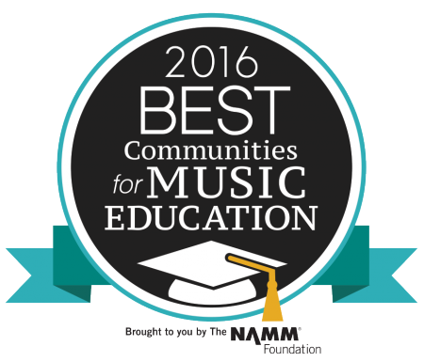
Wakefield, MA (April 26, 2016) – The NAMM Foundation has recognized the Wakefield Public Schools for its outstanding commitment to music education with a Best Communities for Music Education (BCME) designation. Wakefield joins 476 districts across the country and one of 18 school districts in Massachusetts receiving the prestigious distinction in 2016.

Now in its 17th year, Best Communities for Music Education affirms school districts that have demonstrated exceptional efforts toward maintaining music education as part of schools’ core curriculum.

The BCME survey requires districts to answer detailed questions about funding, graduation requirements, music class participation, instruction time, facilities, support for the music program and community music-making programs. Responses were verified with school officials and reviewed by The Center for Public Partnerships and Research, an affiliate of the University of Kansas.

“I am very proud of the Wakefield Community, Wakefield Music Boosters and the Wakefield School Department in their continued support of music in the town of Wakefield. This is a K-12 designation, which shows the value that is put on music throughout the school system. Thank you to the school department, parents and especially the music teachers for all of their hard work and dedication to providing a quality music education for all students.” – Thomas Bankert, Wakefield Public Schools Director of Visual & Performing Arts

The Best Communities for Music Education program plays an important part of the
NAMM Foundation’s efforts to make music education part of the core curriculum assuring that the benefits of music making are available to every child. Numerous studies have demonstrated that learning to play music can boost academic and social skills, lower disciplinary action and keep kids in schools.

# # #

About The NAMM Foundation
The NAMM Foundation is a nonprofit supported in part by the National
Association of Music Merchants and its nearly 9,200 members around the world. The Foundation advances active participation in music making across the lifespan by supporting scientific research, philanthropic giving and public service programs. For more information about The NAMM Foundation, please visit www.nammfoundation.org.

